Season's Grievances: of Love and Gunpowder

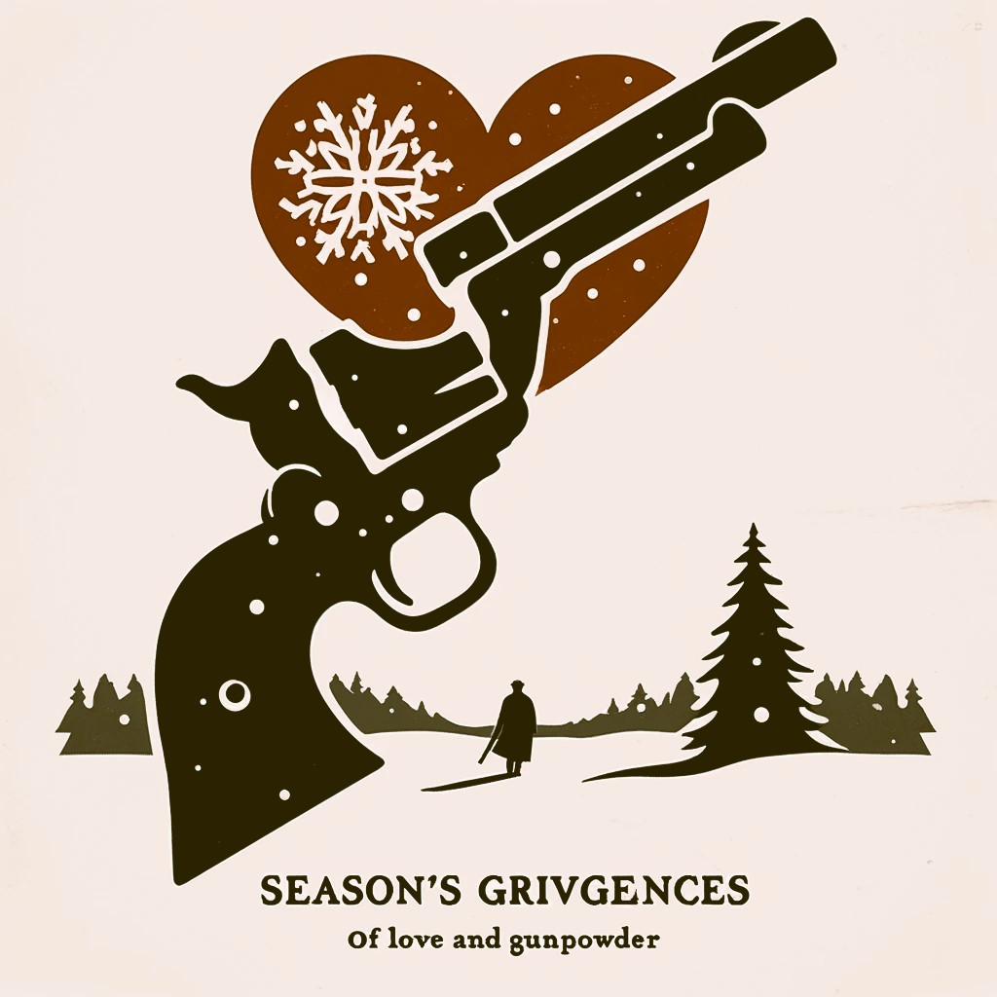
By Adam Stratmeyer

"Season's Grievances: of Love and Gunpowder" derives its title from the chaotic events that unfolded during the Christmas break, akin to the action-packed narrative of "Die Hard," albeit set in the backdrop of law school drama and legal entanglements.

"So this tale takes place in Vermillion SD during my time in Law School, like so many others. To tell it accurately and to tell it about the people involved isn't quite possible, so I'm taking quite a lot of liberties with this, but rest assured the core story remains relatively intact. Nate, one of my roommates in law school, was one of my best friends, though you may or may not already know this. We were in our final year, final semester of Law School and grad school, after enduring various schools for what felt like a decade of our lives, being older than we should be but still living as if we were in our 20s, even though we were in our 30s.

My roommate, Nate, was an officer in the Law School fraternity, so our house was often utilized for a lot of social gatherings and events, which is essential to how this story unfolds. However, it all started in Rapid City, again, during the last semester of the last year of Law School, only months left till graduation. Nate and I were home for Christmas, indulging in all the things we wanted to indulge in. I wanted to stay in Rapid City for a few more days. There was a blizzard on the way, and we were due back in Vermilion relatively soon to continue attending classes, or rather, pretending to attend classes, ditching classes, or whatever we happened to do at the time. It's a bit of a haze, to say the least, but again, there was a blizzard, and I was less than encouraged to leave. I had a good time in Rapid during this break; it was a comforting form of debauchery, and I was not excited to go back to a place that had been sucking me dry, at least not right away and not through a blizzard.

Nate, on the other hand, was adamant about returning, almost foaming at the mouth. Seeing as he was the one with the truck and was driving, I had little option but to agree.

As we started back, venturing east across the state of South Dakota, five to six to eight hours depending on how you go about it and what the weather is like, Nate was texting more frequently than usual, which was kind of peculiar. After our first time going in the ditch and almost dying, something that you get kind of familiar with living in South Dakota, I decided to take a quick peek at his phone. Because it had left his hand in our most recent brush with mortality. What I saw made sense. 'What the fuck,' I said. 'This is why we're fucking heading back to Verm, risking our lives in a fucking blizzard.' The conversation was basically some type of juvenile chat back and forth between him and a junior law student who we had been courting for some period of time. They had not had romantic relations, and I considered her to be a Cock tease and bit of a flirt, but Nate seemed determined to pursue her.

Fine, I said, I get it. I can't really blame a guy for chasing pussy, but I was really unhappy about the fact that he was chasing this particular variety of pussy. Nothing against the girl; she was just doing what girls do, but Nate seemed a bit unhinged. Not to mention the fact that he already had quite the animosity towards women, despite his ability to acquire the companionship of a few attractive ones. He wasn't keen on rejection and was relatively prone to violence under the influence of alcohol. But I wasn't free of sin, and if it meant forging through a blizzard in the hopes of getting laid, that would be fine. Besides, I actually had a rendezvous with an old friend in Vermilion, Melissa. Yes, that Melissa. She was going to be in Vermilion at the same time as we were arriving, a fact I found out about half way across the state. It was as though I was unjustly enriched yet again, and it felt like I was taking a chunk of Rapid with me. Our friendship and familiarity were a great thing to behold, so I was looking forward to meeting her there."

"As per usual, we made it back to Vermilion by the skin of our teeth. I'm sure I was inebriated. That drive is too long to not play malt liquor monthly but Nate tended to hold himself a little better than I did, ever implementing his strategy of being one of the last guys standing in the wee morning hours, whereas I would lose consciousness as soon as possible. That's 'protecting me from probably a bunch of horrible life decisions,' as my old saying goes, but by the grace of God, there go I.

We rolled into our abode, and Kyleour other roommate, was already there. I had brought treats back from Rapid, a little bit of nose candy for the old Good Times' sake, and laid some out on our wonderful mirrored coffee table as we exchanged gifts. But there wasn't enough time for recanting, as the bar was calling. Within an hour of being back in town, we were out and about, at least Nate and I were. I had a rendezvous with Melissa, and he had a rendezvous with something completely different.

What proceeds now is sort of entirely my perspective. Accounts and variations differ, and I have tried to get a fair take on this from various people that were present. But as far as my perspective goes, it basically went down like this:

We left the house after our pre-celebration party and ended up at the first bar, both Nate and I together, where I met up with Melissa. Nate was still horribly glued to his phone, engaging in what could only be described as self-destructive behavior. I remember having some choice words on the matter as I sat down next to Melissa, something to the effect of 'Why the fuck are you engaging with this bitch? She's not worth it; she's just fucking with you. And if she was going to fuck you, she would have fucked you by now.' Neither of us were one for tact at the time, but I, in my libertarian sense of the world, An personal responsibility enthusiast. pretty much figured to just let him go about his business, and it would happen as per usual. Every squirrel finds a nut one day, and hey, Nate had found more than his fair share through his own resources. I had said my piece so it was to him.

So, I turned my attention to Melissa, and we proceeded to drink in our usual fare of long-term friendship, always being able to pick up where we left off. Romantic entanglements were not at all on our minds. It had been a long day, and Melissa and I decided to retire back to the house, taking up positions in the bed as per usual. We fought our natural urges and actually decided to go to bed. To my recollection, this was early, around 10:00 to 11:00 p.m., but like I said, it had been a long day.

I must tell you, sleep can be an elusive bitch when you're fighting a moral quandary regarding sexual arousal, but she and I were no strangers to it and managed to gain some form of slight sleep until what apparently seemed to be about 1:30 to 2:00 a.m. happened."

"I had warned Melissa of this. I knew it was coming—the after-bar swarm. Something I never had any interest in after about age 32, but for Nate, it was a key essential element to his successful attempts at conjugal enjoyment and general fucking. Plus, some people are just more social than others. We heard the door slam, and people came rolling in. I didn't know who was there; I could maybe make out a few voices, but it was the standard thoroughfare. I could hear standard bar flies, law school students, and a few voices that I really couldn't make out.

'What the fuck,' Melissa said. 'I warned you.' 'Try and sleep through it; it's just a party, motherfucker.' So, she and I continued to garner what rest we could. It was very shortly after that—I can't really state how long, maybe half an hour—that there was a pounding THUD THUD on my door. Not so much a knock but a meat hammer thumping my door. It was a Friend, fellow Law student, and general asshole, Russell, of drinking competition and MDMA manufacturing fame. He spoke, 'Hey Adam, you should maybe come downstairs; Nate's acting really kind of out of control, and I don't really know.'

My piss was brought to a boil. 'I have company; we are trying to rest. You are adults with college degrees; figure it the fuck out,' I retorted back angrily, as I returned to bed, leaving Russell and his concerns behind. But another duration, similar to the last, transpired. We could hear upset voices, yelling, noises again—something not atypical for an after-bar party. Then we heard everyone go quiet for a brief second, followed by a loud female scream, and the unmistakable click-bang of a gunshot, followed by another female scream and then quietness.

Melissa, for the third time, 'Dude, what the fuck?' I believe my retort was, 'Oh no,' in an almost nonchalant way. There were several possibilities, and I wasn't quite sure which one it was, but I had a feeling there might be someone in my living room right now that turned into a fine pink mist and was now decorating the walls of my duplex. However, like most of the people present, or not, I was unfamiliar with gunfire. I wasn't uncertain whether or not someone would be coming up to try and kill us, but I figured since there was only one gunshot, the situation had at least somewhat resolved itself.

There was a rap tap tap on the door again. Once again, I took my boxer-wearing ass over to the door, this time with my trusty .357 revolver in hand. I cracked open the door to see Nate standing there, not at all distressed but almost elated, looking at me. He said, 'Well, that's one way to end a relationship,' as his hand protruded forth, extending the Glock to me, while he said, 'Here, take this.' I swear, I'm a sucker, the easiest one to get. It's so easy to get me to do something as long as you just sneak it into a conversation nonchalant. I grabbed that gun, much as I'd dump a soft cough drop into my hand, and immediately regretted it. But I was in it now and figured, as drunk as I was, as pissed as I was, it was probably time to rally as best as possible.

Kyle, being what he was, stuck his head out of his door. He hadn't been participating in any of this crazy shit the whole time but was the third roommate. We all stood there in our different states of human existence. 'All right,' I said. 'Get all the drugs you have and get them out of here, flush them, get rid of anything illegal, contraband, whatever we might have. As far as the guns go, unload them. I have a feeling the cops are probably coming.' Everyone went to work trying to figure out what the fuck to do with everything."

"I had it downstairs immediately, just to go survey the situation. It hadn't been made clear to me whether or not Nate had killed her. I mean, I'm assuming not, as the situation didn't really warrant that. And as I walked down, I saw this frantic display: first-year law students crying, people freaking out, some threatening to call the cops. The first-year law students were terrified that they wouldn't be able to do anything since they dare not retaliate against us for anything that we did, which, to this day, I feel is a little fucked up.

I immediately swiped the narcotics off the glass coffee table, unloaded Nate's Glock, and placed it clearly on the table. I yelled at the crying younger students to shut up, telling them it was just gunfire and to get the fuck over it. 'No one's dead,' I said. Then, I had to proceed to figure out what was going on with the girl he discharged the firearm at. What later turned out to be the girl and a fraternity boy were departing the scene. Did I mention that it was about -40 F below that night in the charming part of Eastern South Dakota? One of those frigid winter nights where you could die pretty quickly just from walking somewhere, even though Vermilion was traversable easily by foot if you pushed it.

I ran outside, running after what apparently was the scorned love. I had to check on her. I asked her if she was okay. She said, 'Dude, it's no big deal. He's messed up; it's not the first time I've been shot at. It's not a big deal.' I'm like, 'All right.' She's like, 'I'm not going to call the cops.' Coming jogging down the street after me was another student who decided he would take upon the duty of taking care of the poor traumatized girl after the fact—quite the scavenger, if you would, but the circumstances would allow for it.

Then I had more important things to deal with, like getting inside before freezing to death. So, I went back inside, and people were threatening to call the cops. This was not in anyone's best interest, but Russell was an uptight bitch when push came to shove, and there was no way I was going to tell some girl that she couldn't call the cops in that situation, especially not one studying law. I tried my best at the point of reason, but quite a bit was put on me at this point. 'Nate needs help,' they would proclaim. I'm like, 'That might be true, but maybe we can't deal with this at this point. I also have no idea who had or hadn't called the cops and figured it would be best on our end to be proactive and take control of this situation, better than not.'

On reflection, not my best call, but every decision that we've all made has been made with only partial information available to us. I did the best I could."

"So, what actually happened during my subsequent rest and recuperation with my friend was that Nate had constantly been antagonized by the girl, much like I said she would. If he had walked away, like we all should always do, things might have been fine. But no, Nate continued to drink, and she continued to taunt. Finally, it was last call at the bar, and Nate invited everyone back to our place, as per usual, seeing as it was close enough that they wouldn't freeze to death on the walk. Not like everyone wasn't too messed up to avoid, at least what they felt or the physical effects of 40 to 60 below weather.

During the last bar, said interest of Nates Not girlfriend or even fuckbuddy was flirting heavily with what could only be described as a douchey frat boy. They were in great abundance in Vermilion—terrible people, but as the girls would often say, good to look at and at least worth fucking. Nate didn't take too kindly to this and was quite irritated, while everyone was out in the garage smoking cigarettes and what have you. He got into an altercation with the girl and happened to remove some of her hair. That's when Russell came and disturbed me again. These are people in their 30s, maybe late 20s at the earliest, 90% holding college degrees, if not advanced degrees.

I mean which was unusually particular considering how everyone interacted back in the day. I considered writing another part of this story called my first restraining order, a guide to dating in law school but that never really came to fruition.

